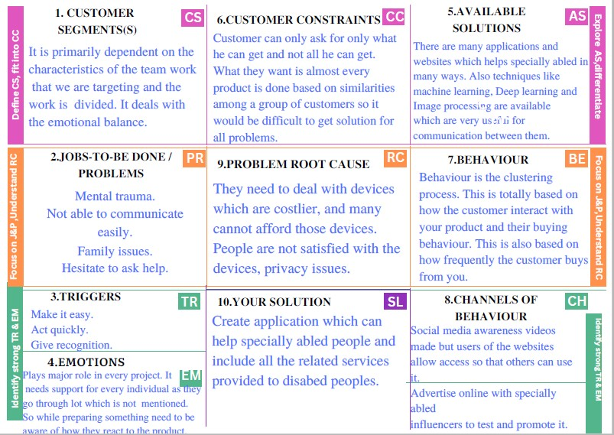
REAL TIME COMMUNICATION SYSTEM POWERED BY AI FOR SPECIALLY ABLED
PROJECT DESIGN PHASE -1 SOLUTION FIT TEMPLATE
Domain name: Artificial Intelligence

Team ID: PNT2022TMID12678

Team leader: Kavya sree R
1.Janani D
2.Logasheneha P
3.Priyadharshini A

Project Design Phase -1- Solution Fit Template

Project Title: Real Time Communication System Powered by AI for Specially Abled
Team ID: PNT2022TMID18994

